**INFO-3111 Summer 2023 – **BONUS** Checkpoint/project**

|  |
| --- |
| **Due:** At the start of class, **Wednesday, June 28th @ 11:59 PM** (“mid-night”) |
| **Submit:** Your screenshot to the submission folder in FOL |
| **Worth/weight/mark value:** 10% |
| **This is an entirely optional bonus checkpoint/project** |

Using selected models form the Synth Studios “Dungeon” models, create a 64 bit Win32 (Windows 7/8/10) + OpenGL 4.x application that displays this scene:

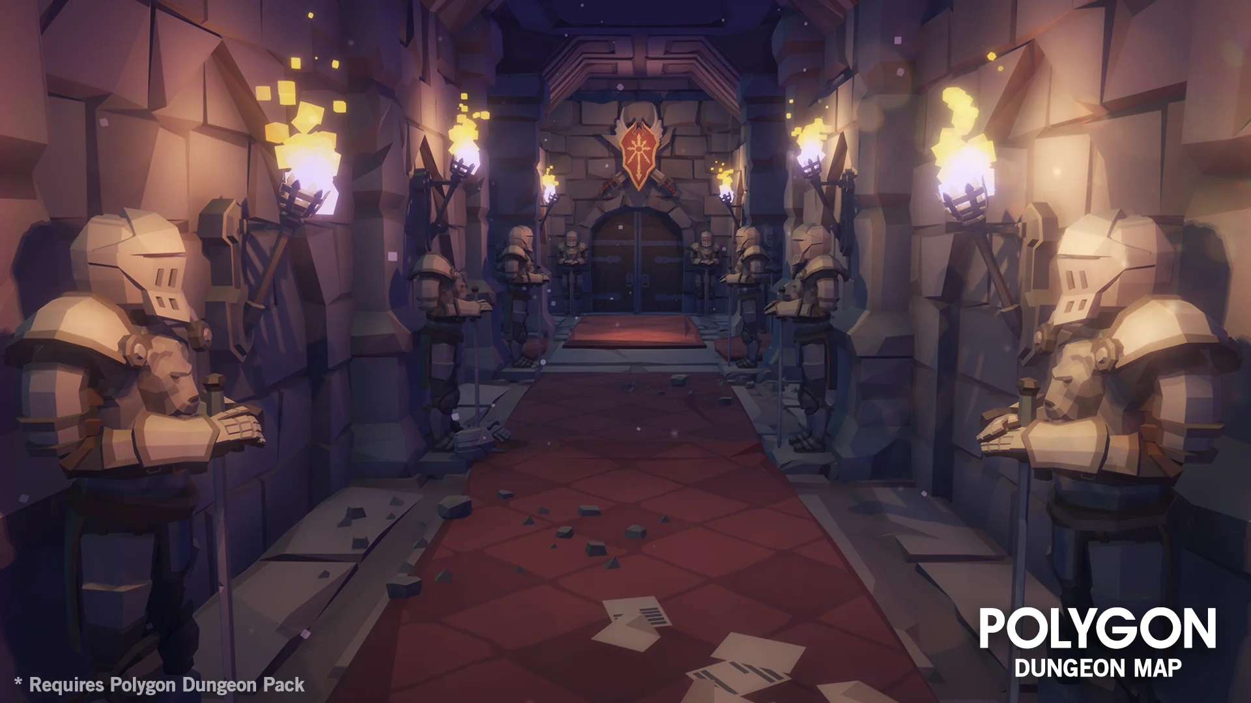

This is the “Synth Studios Dungeon Hallway.jpg” file, if you’d like to examine a higher resolution image.

This image is from the “POLYGON – Dungeons Map” asset pack found here:   
<https://syntystore.com/products/polygon-dungeons-map>

Note that you don’t have *all* the models from the asset packs, but enough selected ones that you can complete the above image (more or less).

**If your submission doesn’t build, I will assume it can’t run, and you will get a mark of zero.**

**It MUST build and run in RELEASE mode (64 bits).**

(I *might* do something minor like try to unzip the libraries files that github stripped out or something along those lines, but I should be able to download it, build it, and run it, without incident.)

Warning level 3 is fine. In fact, I’ll almost certainly completely ignore any “warnings”.

**No “boost” library or “auto” keyword. Use of these will give you a mark of zero, no exceptions.**

1. (10 marks) Basic placement of the items in the scene (ignoring texturing and lighting).

You’ll have to use some alternative models:

* The “knight” statue can be one of the “SM_Env_Statue” models. There are three “angels” and one “knight”, but it’s not the same knight in the image – that knight model is a skinned mesh model, which we haven’t covered.
* The swords on the back wall, above the double doors, are not in any of the Synth Studio packs (or at least I couldn’t find the exact match), so pick one that you’d like. The swords will have to be placed in the same orientation, etc.
* The “wall archway” things – the ones between the knights – are a specific model, but you can also make something similar with a doorway + a wall.

|  |
| --- |
| **I’ll be somewhat flexible on what you pick, if it’s very close to what’s used in this image.  They are a combination of wall tiles, pillars, roofs, etc.**  **HOWEVER, while this question isn’t worth a lot of marks, if you don’t have something that looks almost identical to the image (in terms of models), then you’ll lose a proportional amount for the remaining items.**  **For example, if you slap a few models into the scene, you’ll potentially get no marks for the remaining items. You’re trying to mimic this scene and choosing and placing models is fundamental.** |

1. (30 marks) Correct overall lighting that more-or-less matches what the image has. Note that this image clearly uses a number of lights in the scene (i.e. not just one). Also not that the objects aren’t “washed out”, have a specific specular highlight “look”, etc.
2. (10 marks) The carpet. There is no “carpet” model, but you’ll notice that the right side of the “Dungeons_Texture_01.png” texture is the same as the carpet in the picture. To mimic this, you can use a 2D rectangular “quad” (like two triangles) that have texture coordinates that match the right side of the image. In other words, you’ll have to place a “quad” model very close to the ground, on top of the floor tiles, and set up the texture coordinates so they show only the “carpet” portion of the textures. With a simple quad, you can manually set up these coordinates (a quad being only two triangles with 4 vertices).

The ”far” carpet (near the double doors) is a floor tile with an red/orange colour/texture.

1. (30 marks) The torches, part 1: The torch model is the “SM_Prop_Torch_Ornate_02”.

The “fire” is a collection of cubes, placed in various angles and different colours: note that the ones at the bottom, right inside the torch, are bright white, while the cubes get more yellow in colour the higher up they go.

There is a bright point light illuminating the wall, that’s coming from the brightest part of the torch.

Note that this light likely won’t illuminate the cubes in the “fire” – you’ll need to make the cubes bright with an emissive component of the light.

The cubes get smaller as they get further from the torch.

There’s approximately 20 cubes in each torch. I’m not going to count them, but if you put only a few cubes in each torch, then you won’t get very many marks.

1. (BONUS: 10%) Use quads to mimic the scattered “papers” that are near the front/bottom of the image.
2. (BONUS: 20%) Animate the “cube fire” in the torches. The effect should be:

* The cubes appear at inside of the torch at a random orientation and bright white.
* The cubes slowly “float” up, slowly rotating at random speeds. Specifically, each cube will have some random rotation and movement speed, and that speed will stay constant, but *each cube* has it’s own random speed – so no two cubes will have the same movement and rotation speed.
* There is also some gradual displacement in the X-Z plane – i.e. the cubes “spread out” a little bit, giving the fire some general “fire” shape.
* The cubes get smaller and more yellow as they get further away from the base of the torch.
* Eventually, the cubes get so small, they disappear.